6/20/2025
System Design Document Template
Exam Paper Preparation System
Büşranur Atalay
Dilara Önal
Hasan Kıvrakdal
Kerem Salih Erol

Revision History
Date | Version | Description | Author
20.06.2025 | V1 | V1 | Büşranur Atalay  Dilara Önal  Hasan Kıvrakdal  Kerem Salih Erol

Table of Contents
1. Introduction 1
1.1. Purpose of this document 1
1.2. Identification 3
1.3. Scope 4
1.4. Relationship to Other Plans 5
1.5. Methodology, Tools, and Techniques 6
1.5.1. Methodology: 6
1.5.2. Tools: 7
1.5.3. Techniques: 8
1.6. Constraints 9
1.6.1. Technical Constraints: 9
1.7. Design Trade-offs 9
1.7.1. Flexibility vs. Simplicity: 10
1.7.2. Interoperability vs. Development Overhead: 10
1.7.3. Performance vs. Security: 10
1.7.4. Reliability vs. Rapid Feature Delivery: 10
1.7.5. Usability vs. Security Controls: 11
1.8. User Characteristics 11
1.8.1. User Problem Statement 12
1.8.2. User Objectives 12
2. Background 13
2.1. Overview of the System 13
2.2. Overview of the Business Process 14
3. Conceptual Design 15
3.1. Conceptual Application Design 15
3.1.1. Application Context 15
3.2. Conceptual Data Design 12
3.2.1. Project Conceptual Data Model 12
3.2.2. Database Information 12
3.3. Conceptual Infrastructure Design 14
3.3.1. Special Technology 15
4. System Architecture 16
4.1. .Hardware Architecture 18
4.2. .Software Architecture 20
5. Human-Machine Interface 22
5.1. Inputs 25
5.2. Outputs 25

Introduction
In contemporary academic environments, the preparation of high-quality examination materials remains one of the most time-consuming and repetitive responsibilities of university instructors. While pedagogy and curriculum development have undergone significant digital transformation, the process of preparing examination papers continues to rely heavily on manual effort, fragmented tools, and ad hoc file management. These conventional practices often lead to inconsistencies in formatting, increased error rates, version control problems, and ultimately, inefficiencies in educational workflows.

The Exam Paper Preparation System (EPPS) has been meticulously designed as an intelligent, web-based application tailored specifically to address this persistent academic challenge. It seeks to empower educators with an integrated digital platform that supports the full lifecycle of exam paper preparation — from question authoring to version randomization and secure PDF export. The system's goal is not only to reduce administrative workload for academic personnel but also to establish a standardized, institution-level solution for organizing and managing exam content efficiently.

Through a robust and secure backend infrastructure, combined with a user-friendly interface, EPPS ensures that instructors can focus more on pedagogical quality and question design, rather than the tedious logistics of document preparation. The system is poised to become a critical asset in digital campus initiatives, supporting the modernization of academic assessment processes in universities, colleges, and higher education institutions.

Purpose of this document
The primary purpose of this document is to articulate, in a clear and comprehensive manner, the architectural and component-level design of the Exam Paper Preparation System (EPPS). It serves as a technical bridge between the system’s functional requirements and its actual implementation. This document translates the previously defined requirement specifications into a coherent and detailed blueprint that can be directly utilized by developers, system engineers, and QA analysts during the system’s development and deployment phases.
This System Design Document (SDD) provides an in-depth description of the system’s internal structure, including software architecture, module breakdown, data flows, user interface behavior, and integration points. It defines the interaction between various subsystems, establishes the logic of component communication, and specifies both functional and non-functional design considerations.
The intended audience for this document includes:
- Software developers responsible for coding the backend, frontend, and database modules.
- System architects and designers overseeing the overall structural integrity and scalability of the system.
- Test engineers and QA teams validating the functional correctness and performance of the system.
- Academic technology stakeholders and institutional IT staff seeking to understand the system’s capabilities and integration needs.
By establishing a shared understanding of the design, this document ensures that development efforts remain aligned with institutional objectives, technical standards, and pedagogical requirements.

Identification
This document pertains to the design and development of the Exam Paper Preparation System (EPPS) — a web-based software platform intended to support academic staff in the structured and efficient preparation of exam papers. The following table outlines the system’s identification details, technical framework, applicable standards, and project team members:
Tablo 1. Identification Table
Attribute | Description
System Name | Exam Paper Preparation System
Abbreviation | EPPS
Version | 1.0
Release ID | EPPS-2025-TR
Primary Technologies | Java (Spring Boot), PostgreSQL, Thymeleaf, Apache PDFBox
Repository | GitHub – EPPS
Author | H. Kıvrakdal
Development Model | Modular layered architecture
Team Members | Dilara Önal (System Analyst & Documentation Lead)  Kerem Sarih Erol (Backend Developer)  Büşra Atalay (Frontend Developer)
This System Design Document adheres to the following internationally recognized standards to ensure quality, consistency, and technical validity throughout the system’s development:
- IEEE 1016 – Standard for Software Design Descriptions
- ISO/IEC 25010 – System and Software Quality Models
- ANSI SQL – Standard for Structured Query Language used in relational databases
These standards provide a robust foundation for the system’s architecture, design documentation, and future scalability within academic institutions.

Scope

Tablo 2. Scope Inclusions
Includes
A secure, role-based authentication mechanism enabling differentiated access for academic staff with user and role management
Academic structure management including universities, faculties, departments, and academic programs hierarchy
An intuitive web-based interface developed using Thymeleaf for seamless interaction and navigation.
- Automated exam paper compilation and PDF generation leveraging Apache PDFBox technology.
- Persistent data storage and management through PostgreSQL relational database integration.
- Modular layered architecture to ensure maintainability, scalability, and ease of future enhancements.

Tablo 3. Scope Exclusion
Excludes
Development of mobile or native applications supporting EPPS functionalities.
Multi-language localization beyond English interface support.
- Integration with third-party Learning Management Systems (LMS) or external academic platforms.
- AI-assisted question generation, automated difficulty assessment, or intelligent content recommendation
- Real-time multi-user collaboration or simultaneous editing of exam papers

Relationship to Other Plans
This System Design Document (SDD) serves as a foundational reference within the broader project documentation ecosystem for the Exam Paper Preparation System (EPPS). It establishes a clear architectural and functional framework that aligns with and supports the objectives outlined in related project plans. The interrelationships are as follows:
- Functional Requirements Document [Version X.X]:
The SDD is directly derived from the Functional Requirements Document, translating high-level requirements into detailed design specifications. It ensures that the system architecture and components are aligned with the functional expectations and constraints defined in the requirements phase.
- Configuration Management Plan [Version X.X]:
This document references the Configuration Management Plan to establish guidelines for version control, change management, and traceability of design artifacts. It ensures that all design elements are consistently managed and that modifications are systematically tracked throughout the development lifecycle.
- Software Quality Assurance Plan [Version X.X]:
- The SDD incorporates quality attributes and compliance criteria as specified in the Software Quality Assurance Plan. It outlines the design considerations necessary to meet quality standards, including performance benchmarks, security requirements, and maintainability goals.
- Project Repository:
The design artifacts and implementation code are stored and managed within the project's GitHub repository: https://github.com/EPPS-Project/EPPS. This repository serves as the central hub for version-controlled source code, documentation, and collaborative development efforts.
By maintaining these interconnections, the SDD ensures that the system's design is coherent, traceable, and aligned with the project's overarching objectives and standards.

Methodology, Tools, and Techniques
The design and implementation of the Exam Paper Preparation System (EPPS) leverage an iterative, incremental software development methodology aligned with Agile principles, specifically Scrum practices. This methodology supports adaptive planning, continuous stakeholder feedback, and rapid delivery of working increments to accommodate evolving academic requirements.

Methodology:
- Agile Scrum Framework:
Iterations (Sprints) of 2 weeks are employed to enable frequent releases, allowing stakeholders (academic staff and administrators) to validate design decisions and suggest refinements promptly. This enhances responsiveness to requirement changes and promotes collaborative development.
- Test-Driven Development (TDD):
Unit and integration tests are defined before coding modules, ensuring high code coverage and reducing defects. Automated testing suites are integrated into the CI/CD pipeline for continuous verification.

Tools:
- Version Control and Collaboration:
Git, managed via GitHub, supports branching strategies such as Git Flow for parallel feature development, release preparation, and hotfix management. Pull requests undergo mandatory peer reviews to maintain code quality and facilitate knowledge sharing.
- Continuous Integration / Continuous Deployment (CI/CD):
GitHub Actions automate build verification, static code analysis (using SonarQube), unit and integration testing, and deployment to staging environments, ensuring reliable and repeatable delivery cycles.
- Design and Modeling:
UML diagrams (class diagrams, sequence diagrams, component diagrams) are created with PlantUML and draw.io. These models document system structure, data flows, and interactions, facilitating clear communication among developers and stakeholders.
- IDE and Build Tools:
IntelliJ IDEA is the primary Integrated Development Environment (IDE) for Java development. Maven handles dependency management and build lifecycle automation, streamlining project builds, test executions, and packaging.
- Database Management:
PostgreSQL is utilized for its ACID compliance, advanced indexing capabilities, and support for complex queries. Database schema design emphasizes normalization to minimize redundancy, with stored procedures to encapsulate business logic where appropriate.
- Frontend Development:
Thymeleaf serves as the server-side rendering engine integrated within Spring Boot, ensuring seamless HTML templating, dynamic content generation, and form processing with enhanced security features like CSRF protection.
- PDF Generation:
Apache PDFBox is used to dynamically create and manipulate exam paper documents in PDF format, supporting template-based generation, encryption, and metadata embedding.

Techniques:
- Layered Architecture:
The modular layered design segregates responsibilities into presentation, business logic, and data access layers. This separation improves maintainability, testability, and scalability.
- Design Patterns:
Core design patterns such as Repository, Service, Singleton, and Factory are applied to promote reusable, loosely coupled components.
- Security Practices:
Role-Based Access Control (RBAC) and OAuth 2.0 mechanisms enforce user authentication and authorization. Input validation, sanitization, and HTTPS are used to mitigate common web vulnerabilities like SQL injection, XSS, and CSRF.
- Change Request Management:
Feature enhancements and defect fixes are tracked via GitHub Issues, linked to commits and pull requests to maintain traceability and audit trails.
This comprehensive toolset and methodological approach ensure robust, maintainable, and high-quality system design and implementation.

Constraints
Several critical constraints shape the design, implementation, and deployment of EPPS:

Technical Constraints:
- Technology Stack Commitment:
The choice of Java with Spring Boot, PostgreSQL, Thymeleaf, and Apache PDFBox is mandated by institutional technology standards and existing expertise within the development team. This limits the adoption of alternative frameworks or databases.
- Browser Compatibility:
The system must support contemporary browsers (Chrome, Firefox, Edge) with no guarantee for legacy browser compatibility, due to resource prioritization.
- Infrastructure Limitations:
Deployment must operate within the university’s existing IT infrastructure, which imposes constraints on server specifications, network bandwidth, and storage capacity.

Design Trade-offs
Design decisions for EPPS involved careful evaluation of competing system attributes. The following key trade-offs were considered and justified:

Flexibility vs. Simplicity:
- A modular, layered architecture provides extensibility for future features (e.g., AI-based question suggestion, LMS integration). However, to reduce initial system complexity and accelerate delivery, the first release limits configurability and advanced customization options.
- Simplifying workflows enhances usability but reduces flexibility for power users; the design strikes a balance by allowing basic customization with a clean interface.

Interoperability vs. Development Overhead:
- Full integration with external academic systems (e.g., LMS, student information systems) would streamline workflows but require significant development and maintenance resources.
- Initial focus is on well-defined APIs and standard-compliant data formats to enable future integrations without overburdening the current release.

Performance vs. Security:
- Strict security controls, including encryption, multi-factor authentication, and access control, add processing overhead that may slightly impact system responsiveness.
- Performance optimization is prioritized for critical paths such as PDF generation and database queries through indexing, caching, and asynchronous processing to mitigate this impact.

Reliability vs. Rapid Feature Delivery:
- Emphasis on robust error handling, transactional integrity, and automated testing ensures system reliability and data consistency, even if it extends development time.
- Features undergo staged rollout with beta testing phases to minimize risk while enabling continuous improvement.

Usability vs. Security Controls:
- Implementing comprehensive role-based access control enforces strict permissions, which may increase user onboarding complexity.
- To offset this, the UI incorporates guided workflows, contextual help, and clear feedback mechanisms, improving user experience without compromising security.
These trade-offs represent deliberate prioritizations driven by project goals, user needs, resource availability, and operational environment. The architecture accommodates incremental enhancements to rebalance these attributes as the system evolves.

User Characteristics
The primary user community of the Exam Paper Preparation System (EPPS) consists of academic staff, including lecturers, exam coordinators, and administrative personnel involved in exam creation and management within the university. Users typically have varying levels of technical proficiency:
- Academic Staff: Generally proficient with standard office software (MS Office, email clients) but may have limited experience with specialized exam preparation tools.
- Administrative Staff: Moderate technical skills focused on data entry and document handling.
- IT Support Team: Advanced technical expertise, responsible for system maintenance and troubleshooting.
Most users expect an intuitive and streamlined interface that minimizes learning curve and reduces manual workload.

User Problem Statement
Users currently face significant challenges in preparing exam papers, including:
- Manual Paper Preparation: Use of disconnected tools (Word processors, spreadsheets), resulting in inconsistent formatting and errors.
- Time-consuming Assembly: Difficulty in aggregating questions from multiple sources, leading to inefficiencies.
- Lack of Version Control: No centralized tracking of changes, causing confusion and duplication.
- Limited Collaboration: Difficulty in coordinating among multiple lecturers or departments.
- Non-automated Document Generation: Manual PDF creation and distribution increases risk of mistakes and delays.
These problems result in wasted time, reduced accuracy, and increased administrative burden.

User Objectives
- The users require a system that:
  - Automates exam paper assembly from pre-existing question banks.
  - Supports multi-user collaboration with role-based access.
  - Provides consistent formatting and standardized document templates.
  - Maintains version control and audit trails of changes.
  - Allows easy preview and PDF generation of exam papers.
  - Offers an intuitive web interface accessible across devices.
  - Ensures secure access, protecting exam content confidentiality.
- Wish List:
  - AI-assisted question suggestion based on syllabus and difficulty.
  - Integration with the university’s Learning Management System (LMS).
  - Customizable exam templates.
  - Analytics on exam paper composition and difficulty distribution

Background
The Exam Paper Preparation System (EPPS) addresses the critical need for a centralized, automated solution for exam creation at the university. Traditionally, exam preparation has been manual and fragmented, leading to inefficiencies and quality issues. EPPS consolidates question management, paper assembly, formatting, and distribution into a single web-based platform.
By streamlining the entire process, EPPS aims to improve productivity, accuracy, and collaboration among academic staff, while ensuring standardized, high-quality exam papers. The system also enhances security and version control, which are essential for maintaining exam integrity.
This project is part of a larger university digital transformation initiative aimed at modernizing academic processes through smart, automated solutions.

Overview of the System
EPPS is a web-based platform that enables lecturers and exam coordinators to:
- Manage question banks categorized by subject, topic, and difficulty.
- Select and assemble questions into exam papers using predefined templates.
- Preview exam papers with consistent formatting.
- Generate secure, standardized PDF documents for printing and distribution.
- Collaborate through user roles and permissions with audit trails.
- Manage versioning to track changes and revisions.
The major users are lecturers who create and edit exam papers, exam coordinators who oversee quality and compliance, and administrative staff who handle distribution. External parties include printing services that receive finalized PDF documents.

Overview of the Business Process
The EPPS supports the following core business processes:
- Question Bank Management: Lecturers input, categorize, and review questions.
- Exam Paper Assembly: Authorized users select questions and apply templates to compose papers.
- Review and Approval: Coordinators review assembled papers, request modifications if needed.
- PDF Generation and Distribution: Finalized papers are exported as PDFs for printing and archival.
Below is a high-level data flow describing the interaction among system components and users (example diagram reference):
Tablo 4. Business Process
Process ID | Process Name | Description | Actors
BP001 | Manage Question Bank | Enter and categorize questions with metadata for retrieval | Lecturers
BP002 | Assemble Exam Paper | Select questions and apply templates to create exam papers | Lecturers, Coordinators
BP003 | Review Exam Paper | Review, comment, and approve assembled papers | Coordinators
BP004 | Generate & Distribute | Convert papers to PDF, secure documents, and distribute to printing/external parties | Admin Staff

Conceptual Design

Conceptual Application Design

Application Context
The system is designed as a centralized academic management platform that interfaces with multiple external systems and services to provide seamless functionality. The core application handles user authentication, exam management, and academic record processing.

Application Context Diagram Overview:
- Core System: Centralized Academic Management Application (subject of this design).
- External Systems:
  - University Identity Provider: Handles Single Sign-On (SSO) and user credential validation.
  - Learning Management System (LMS): Interfaces for course content and grade synchronization.
  - Document Storage Service: Cloud-based repository for storing encrypted exam papers and student records.
  - Notification Service: Email and SMS gateway for sending alerts and notifications.
- Subsystems:
  - Exam Scheduling Module: Manages exam dates, locations, and invigilation assignments.
  - User Access Control Module: Enforces RBAC policies and logs access events.
- Data Stores:
  - Relational Database: Stores core academic data and user profiles.
  - Encrypted File Storage: Holds sensitive exam papers and confidential documents.
This architecture ensures modularity, scalability, and security by clearly defining boundaries between components and utilizing secure communication channels (e.g., HTTPS, VPN tunnels) for all integrations.

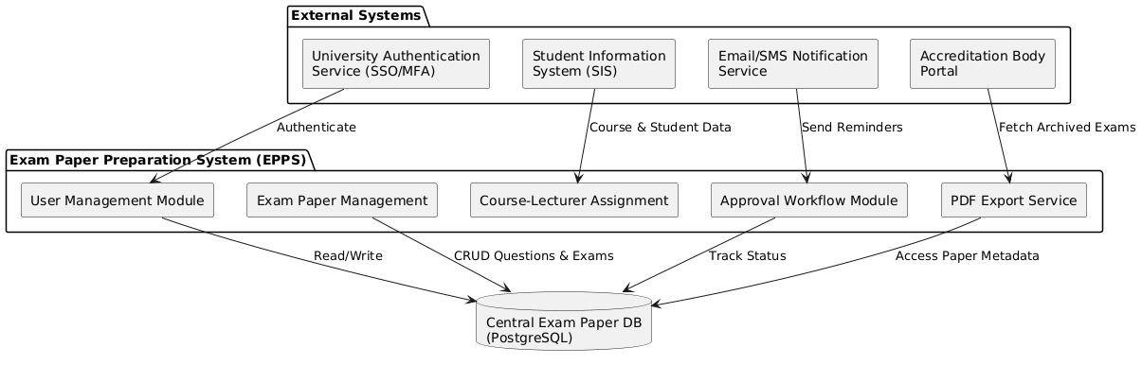
Şekil 1. Application Context Diagram

Conceptual Data Design

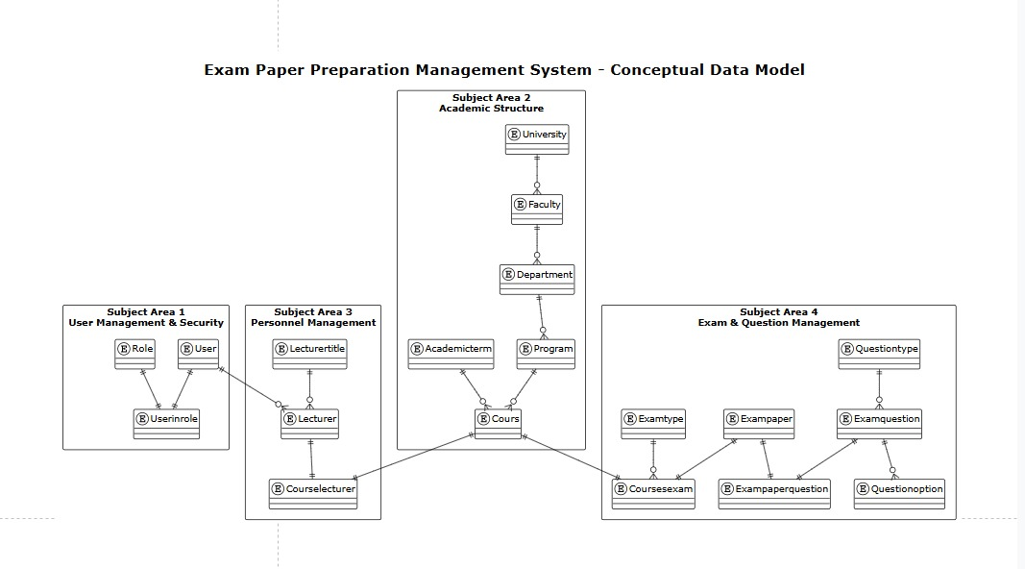
Project Conceptual Data Model
Şekil 2. Conceptual Data Model

Database Information
Tablo 5. Database Inventory
Database Name | Description | Type | Steward
exampaperpreparationmanagementsystem | Main application database storing all exam preparation system data including users, academic structure, questions, and exam papers | Create | Application Development Team
university_academic_db | Existing university academic database containing student records and course information | Interface | University IT Department
user_authentication_db | Central authentication database for university-wide user management and SSO integration | Interface | University Security Office
backup_epps_db | Backup database for disaster recovery and data archival of exam preparation system | Create | Database Administration Team
reporting_warehouse_db | Data warehouse for analytics and reporting purposes, aggregating exam and question statistics | Create | Business Intelligence Team
file_storage_db | Database for managing PDF exam papers, question images, and document metadata storage | Create | Application Development Team

Conceptual Infrastructure Design
The Exam Paper Preparation Management System will operate as a web-based application on the university's existing IT infrastructure. The system is designed to serve academic staff securely and reliably.
The system will operate in three main environments: The production environment will be available 24/7 on the main campus for daily use by academic staff, the test environment will be located in a separate area for system updates and user acceptance testing, and the development environment will be located in the IT department as a workspace for the software development team.
Modern Java technologies will be used as the technology infrastructure. The main application will be developed with the Spring Boot framework, and MySQL relational database system will be preferred as the database. For security, integration with the university's existing authentication system will be provided and role-based access control will be implemented. As a special feature of the system, professional exam papers will be automatically generated in PDF format using Apache PDFBox technology.

Special Technology
Tablo 6. Special Technology Requirements
Special Technology | Description | Notional Location | TRM Status
Apache PDFBox Library | Java-based library for creating and manipulating PDF documents, specifically used for automated exam paper generation and formatting with custom templates | Application Servers in University Data Center | No
Spring Security Framework | Comprehensive security framework providing authentication, authorization, and protection against common attacks, integrated with university LDAP/Active Directory | Application Servers in University Data Center | Yes
Thymeleaf Template Engine | Modern server-side Java template engine for web applications, enabling dynamic HTML generation for exam creation wizards and user interfaces | Application Servers in University Data Center | Yes
MySQL InnoDB Storage Engine | Transactional storage engine providing ACID compliance and foreign key support for maintaining data integrity in academic structure and exam relationships | Database Servers in University Data Center | Yes
Nginx Load Balancer | High-performance web server and reverse proxy providing load balancing, SSL termination, and static content serving for improved system performance | Web Tier Servers in University Data Center | Yes

System Architecture
The Exam Paper Preparation Management System is designed as a web-based application using modern software architecture principles. The system follows a layered architecture approach that separates different functional responsibilities into distinct layers for better maintainability and scalability.
The overall system architecture is based on a three-tier model consisting of presentation, business logic, and data storage layers. The presentation layer provides the user interface through web browsers, the business logic layer processes exam preparation workflows and business rules, and the data layer stores all academic and exam-related information. This separation allows each layer to be developed, maintained, and scaled independently.
The system uses Spring Boot framework as the core technology platform, which provides enterprise-level capabilities for web application development. The architecture supports role-based access where different types of users (lecturers, administrators, coordinators) have appropriate permissions to access specific system functions. Database integration is achieved through MySQL relational database system that stores all academic structure, user information, questions, and exam data.
Key architectural components include the web interface for user interactions, business service modules for processing exam preparation workflows, database access components for data management, and specialized services for PDF document generation. The system integrates with existing university infrastructure including authentication systems and academic databases.
The deployment architecture is designed as a single application that can be installed on university servers, making it easy to deploy, maintain, and backup. The system provides security through encrypted data transmission, secure user authentication, and audit logging capabilities required for academic environments.
Integration capabilities allow the system to connect with other university systems such as student information systems and central authentication services. The architecture supports future expansion through modular design patterns that allow new features to be added without disrupting existing functionality.
This architectural approach ensures the system is reliable, secure, and maintainable while meeting the specific needs of academic institutions for exam preparation and management workflows
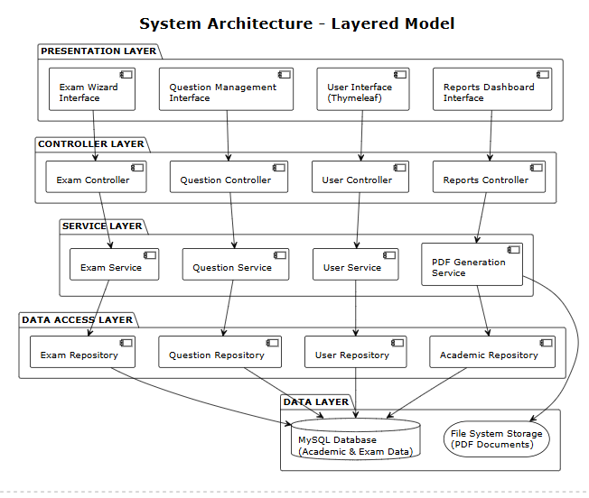

.Hardware Architecture
The Exam Paper Preparation Management System operates on a centralized architecture, with core components hosted in the university’s main data center and user access provided via workstations across campus. The system infrastructure includes:
- Application servers running Spring Boot
- MySQL database servers for storing academic and exam data
- Web servers for handling user requests and load balancing
- Network storage systems for PDFs and backups
The production environment consists of redundant and enterprise-grade hardware:
- Two application servers for high availability
- Primary and backup database servers
- Web servers for traffic distribution
- Centralized storage systems
Supporting environments include:
- A test system in a secondary IT building
- A development environment in the IT department
- A campus-wide network of switches, firewalls, and secure connectivity tools
User access is provided via faculty workstations and administrative offices, with web browsers used for system access and network printers for exam paper output.
Data protection features include:
- Redundant network-attached storage
- Tape libraries for long-term backup
- UPS systems against power failures
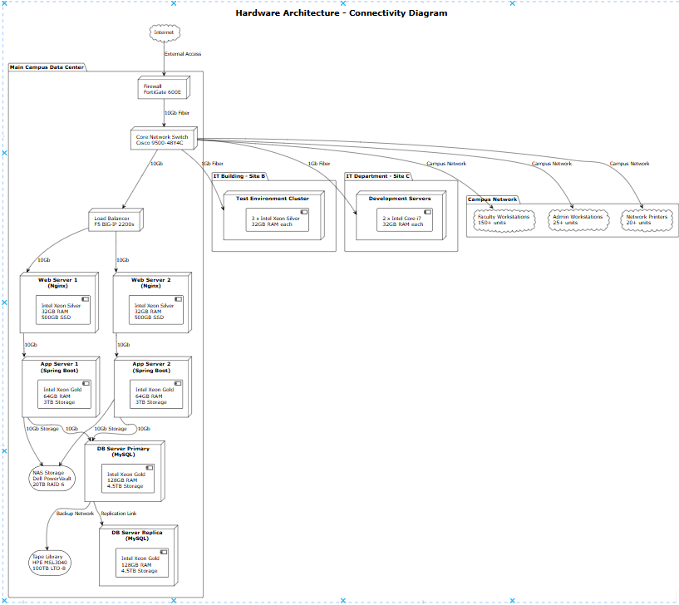
- Cooling and fire suppression systems
The network design follows a hierarchical model with the data center as the central hub, connected via fiber and Ethernet lines. Security measures include firewalls, monitoring tools, and access control systems.
This hardware setup ensures secure, reliable, and scalable system performance across the university, supporting both current use and future growth.

.Software Architecture
The Exam Paper Preparation Management System (EPPMS) is built on a layered, modular web architecture designed to streamline academic exam management. The system uses Java 17 and Spring Boot 3.x, ensuring scalability, maintainability, and modern web standards.
Software Architecture
- Presentation Layer: Web UI with HTML, CSS, JavaScript, and Thymeleaf for dynamic content. Bootstrap ensures responsive design.
- Business Logic Layer: Manages workflows such as user roles, exam generation, and academic rules using Java services.
- Data Access Layer: Uses Spring Data JPA to interact with a MySQL 8.0 database.
Core Modules
- User Management: Role-based access with Spring Security
- Question Bank: Create/manage exam questions
- Exam Generator: Assemble questions into papers
- PDF Creation: Export documents via Apache PDFBox
- Academic Structure: Manage departments, courses, and hierarchy
Technology Stack
- Java 17, Spring Boot 3.x, MySQL 8.0
- Thymeleaf, Bootstrap, Apache PDFBox
- Git, Maven, IntelliJ IDEA, JUnit, logging/monitoring tools
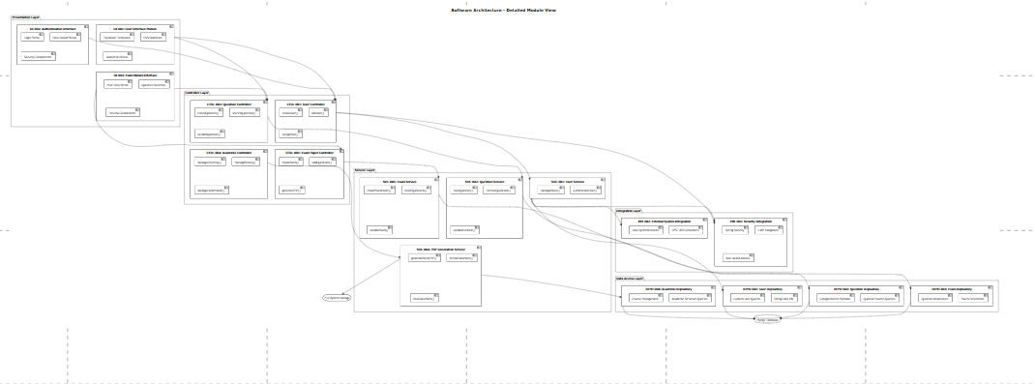

Human-Machine Interface
Human-Machine Interface (User Interface Design)
The Human-Machine Interface (HMI) for the Exam Paper Preparation Management System (EPPMS) has been carefully designed to ensure intuitive, accessible, and efficient interaction between the user and the system. The user interface (UI) was developed using HTML5, CSS (Bootstrap Framework), Thymeleaf (Spring Boot templating engine), and JavaScript, with a focus on usability, responsiveness, and accessibility.
User Profiles & Access Modes
- Administrator: Access to all modules, including system configuration, user management, and full CRUD capabilities across entities.
- Lecturer: Access limited to their own courses and associated exam papers and questions. Can create, edit, and manage only relevant data.
- Authentication: Login interface supports form-based authentication with Spring Security and CSRF token protection.
Each user is presented with a role-specific UI dashboard that dynamically shows or hides menu items based on their access rights.
Interface Layout & Navigation
- Top Navigation Bar: Includes links such as Home, Courses, Questions, Papers, Academic Terms, and User Profile.
- Left Sidebar (if applicable): Provides structured links grouped by function (e.g., "Question Management", "Paper Management").
- Breadcrumbs: Used to indicate page hierarchy for user orientation.
- Action Buttons:
  - Primary actions use Bootstrap-styled buttons (e.g., btn-primary, btn-warning, btn-danger).
  - Icons (FontAwesome) support visual clarity (e.g., ✏️ Edit, 🗑️ Delete).
Input and Output Forms
- All CRUD operations are handled via user-friendly forms:
  - Input fields use proper type attributes (text, email, number, select, etc.)
  - Required fields are indicated with asterisks and validated both client-side and server-side.
  - Layouts use Bootstrap grid system (row, col-md-*) for alignment.
  - Buttons: Save, Cancel, Update, and Delete with distinct color coding
- DataTables are used for record display, enabling:
  - Sorting, searching, and filtering (e.g., question difficulty filtering)
  - Pagination and dynamic loading (planned)
  - Inline feedback (e.g., "No results found")
Responsive Design & Cross-Device Compatibility
- Web-first approach using Bootstrap ensures compatibility across:
  - Laptops/desktops (1366x768 and higher resolutions)
- Elements automatically adjust using media queries and grid system.
- Buttons and links are optimized for touch-friendly input.
Accessibility Features
- All forms and buttons include aria-label and title attributes for screen reader support.
- Keyboard navigation is supported for all major UI components (tab-based focus).
- Color contrast checked for WCAG 2.1 compliance.
- Icons include accessible text descriptions.
Visual Aesthetics and UX Consistency
- Typography: Clear sans-serif fonts like Roboto or system UI font
- Color scheme: Blue and white institutional theme with semantic color coding:
  - Blue (Primary Action), Green (Success), Red (Danger), Yellow (Warning)
- Consistency: Same layout and component styles used across modules to reduce learning curve
Error Handling & System Feedback
- Form validation:
  - Client-side validation using HTML5 + JavaScript
  - Server-side validation messages rendered under input fields
- User Feedback:
  - Toast or modal alerts for actions like create/update/delete
  - Confirmation popups before delete actions
  - 404 and 403 error pages for navigation and permission handling
Interface Examples (Based on Screenshot)
Exam Questions Page:
- Displays question list in a Bootstrap card component with table inside
- Radio button filters for "Easy", "Medium", "Hard"
- Actions include:
  - Add New Exam Question: Opens modal or form page
  - Edit (✏️): Opens the question in editable form
  - Delete (🗑️): Confirmation required before deletion
- Table columns:
  - ID, Exam Question Definition, Type, Point, Actions
Planned UI Enhancements
- Drag-and-drop interface for ordering questions in a paper
- AJAX-based filtering and pagination
- Dashboard analytics (charts on question usage, paper count)
- Night mode / dark theme toggle
- Localization / language switcher (TR/EN)
The current Human-Machine Interface balances clarity, simplicity, and functionality. It ensures that users can easily manage academic tasks such as preparing exams, managing questions, and collaborating with minimal technical training, while also supporting future expandability and integration into larger university ecosystems.

Inputs
- Input Media: Data entry screens accessible via web browser; users can input data through keyboard, mouse, or touchscreen.
- Additional Devices: Barcode scanners and QR code readers are supported for student ID verification and exam paper tracking.
- Input Forms: Structured forms with field-level validation for data integrity. Examples include exam creation forms, user registration, and role assignment.
- Access Restrictions: Input screens are protected based on user roles; e.g., only authorized personnel can edit exam details.
- Security Considerations: Input data is transmitted over encrypted HTTPS channels. All input fields are sanitized to prevent injection attacks. Two-factor authentication is required for administrative functions.

Outputs
- Output Types:
  - Dynamic Data Displays: Real-time screens including exam schedules, user dashboards, and audit logs.
  - Reports: Both scheduled and on-demand reports such as exam attendance records and performance summaries.
  - Notifications: Automated email and SMS alerts triggered by system events.
- Access Control:
Outputs containing sensitive data are restricted to authorized users, enforced through Role-Based Access Control (RBAC) policies.
- Reporting Requirements:
  - Weekly: Exam schedules are automatically emailed to faculty members.
  - Monthly: Compliance reports are generated for auditing purposes.
- Screen Design:
  - Each screen presents context-specific data with filtering and search capabilities.
  - For example, the Exam Dashboard displays exam date, time, location, and invigilator information.
- Design Documentation:
All graphical layouts and data element definitions are maintained in the system design repository.

